Wigston Magna Community Fridge opened in 2018 as an environmental action project. The main aim is to prevent food waste by redistributing surplus food from local shops and help supplement residents' food shopping with fresh produce. The community fridge is open to anyone to come and use. There is no need for a referral or evidence of need, the volunteers will gently encourage fair distribution of goods.
How does the fridge run?
Wigston community fridge open 4 days a week: Mon, Wed, Thu 1:30-2:30 and Fri 10:45-11:45. The fridge may be open for just 1 hour, but with collections and set up, the work involved can take 3-6 hours depending on the day. Opening times on Wigston Community Fridge Facebook page. There are currently 11 volunteers at Wigston community fridge who work shifts to cover food collection and opening hours. They are a strong team with a broad age range from 39 to 82 years old.
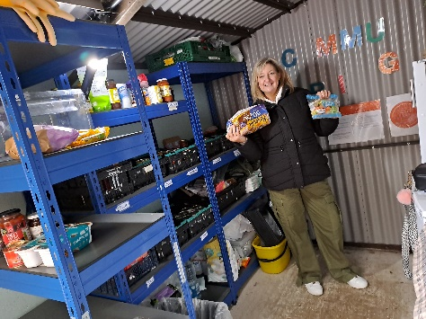
On a typical day, two volunteers open the fridge and set up. We store dried goods in our shed, fresh goods in our fridge. Our volunteers go to a shop or supermarket, take their ID badge, and collect food bags from shop staff. This is dependent on what is available from shops – just after or on best before date. It might be slightly over ripe fruit, bread, pastries - food which the shop is now unable to sell and would previously have been sent to landfill sites.
We see between 20 to 80 residents within our opening hours each day, which keeps us very busy! Staff in our children and family wellbeing department can also make a food parcel for families they are going to see for a home visit. We are fortunate to have a good partnership with many local shops and supermarkets, so we collect from different shops depending on the day.
How fantastic! Tell us more about their support for this project Volunteers collect from the following stores: Co-Op (Enderby) Aldi (Wigston) Lidl (South Wigston) Tesco (South Wigston) Sainsburys (Wigston and Oadby) Asda (Oadby) Milners Bakery (Blaby) Waitrose (Lutterworth). We have a private donator who collects donations herself and receive donations of surplus fresh fruit and vegetables from residents who grow their own fresh produce on local allotments.
Who does this benefit?
The environment The primary aim of this project is to save the planet. We do this by reducing waste food, reducing need for landfill space, reducing gases created by processing waste. From July to Sept 2023 the weight of surplus food we have saved from landfill is 194,284 kilos, which is just extraordinary!
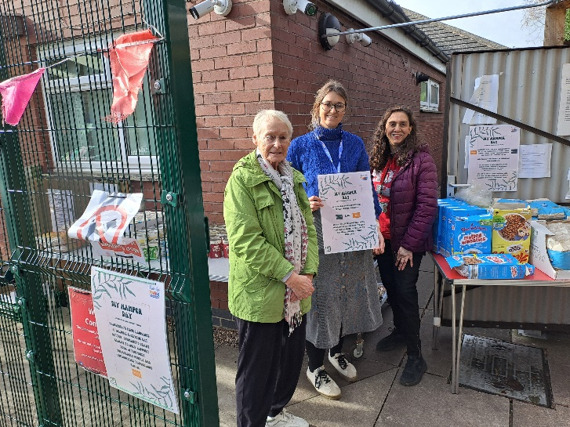
The community Our community fridges really do bring people together. We see them as a strong community asset, which just keep getting better and helping more and more people The volunteers Have a real feel-good factor from their hours at the fridge. They feel positive about helping other residents in the community. They also use the fridge themselves, so directly help reduce waste and share recipe ideas

What do residents who use the fridge say?
“Our Community Fridge is really helpful. I have 4 children who collect the food. It helps them understand how to reduce waste and how much food costs. It’s an opportunity for me to have social time with other fridge users. I am also vegan; the volunteers know this and try to give me the right things” – Friday regular
“One resident comes for whatever is leftover at the end of the fridge opening time, takes them home then makes and shared recipes on Wigston Community Fridge FB page e.g. overripe strawberries into jam, mint leaves into mint syrup. This means there is literally no waste at all. Take a look at ‘The food content you didn’t ask for’ on Facebook” – volunteer

How have things changed over time?
In the beginning, if we had 12 residents within our open hour – that was a good day. We have seen this increase especially since the pandemic. The footfall between July-Sept 2023 was over 2000 residents.
How the fridge is used has also changed - Some residents come every day to take a small amount of food. The fridge is a part of their social life, a reason to leave the house, have a chat, see familiar faces they have got to know from coming here. For those residents we have improved their quality of life and reduced the isolation they were experiencing.
We have linked with colleagues in our Environment team who have supplied the fridge with a hot compost bin to reduce any waste even further. The compost bin is for any cardboard, garden waste, cooked food which will turn into useable compost for plants.
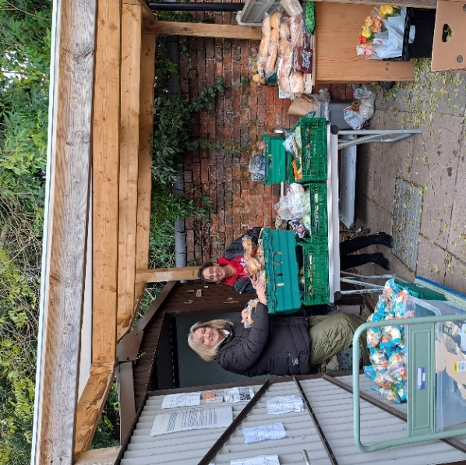
“I could rave about this project all day to anyone! Of the projects I manage across my working week it’s the biggest volunteer cohort, and it has the biggest impact. Families can come to get a meal every day – if we have it, they can take it and feed their family which I think is incredible. The project has such a positive impact on the environment – it really is a win-win for all involved. We couldn’t do it without the volunteers – they do all the leg work. They really are amazing” Natalie, Volunteer Development Co-ordinator
If you are interested in using the fridge, have more ideas for donators to the fridge, want to volunteer for a couple of hours please contact us using our Wigston Community Fridge Facebook page

